**Module 5 Option 1: Interactive Viewer**

Owen Schneider

Colorado State University Global

CSC 405-1: 22 WA

Dr. Li

December 18, 2022

**Interactive Viewer**

**Viewer Functions**

Within the world of computer graphics there are many options to implement an interactive viewer. For an object to be viewed on a device a view port must be implemented. A view port is an area in which a window is mapped. In WebGL this could be seen as the canvas object being mapped to the window. Once the viewport is distinguished many transformations can be applied to the viewport itself, or the object being contained in the view port (“Computer Graphics Window”). This could be seen in the “render()” function. Within render two matrixes are distinguished that update based on user input with sliders. The input then performs transformations on the cube. Most transformations are performed by altering coordinates within the view port. The view port could be considered a three-dimensional grid and all transformations on objects update the coordinates of those objects to alter the view presented to the user.

**Improvements and Differences**

The new program draws a rotating cube using a perspective projection, which simulates the way objects in the real world appear to get smaller as they get further away. The second program draws a cube using an orthographic projection, which does not simulate this effect and makes all objects in the scene appear the same size regardless of their distance from the viewer.

The new program produces a more realistic and visually appealing rendering of the cube, as it simulates the way we see objects in the real world. The second program may be more suitable for certain types of visualization tasks where the relative size of objects is not important.

**Rework Execution**

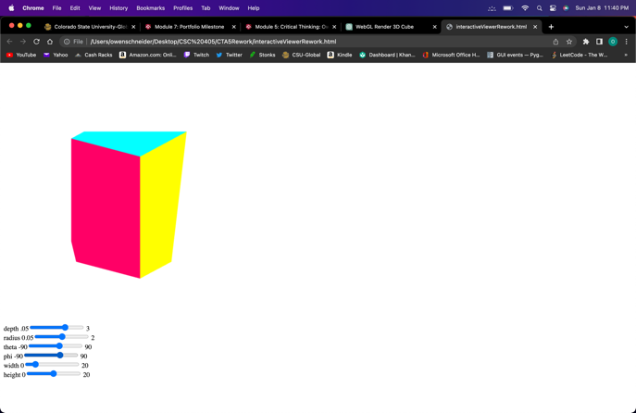

**References**

*Computer Graphics Window - javatpoint*. www.javatpoint.com. (n.d.). Retrieved December 18, 2022, from <https://www.javatpoint.com/computer-graphics-window>